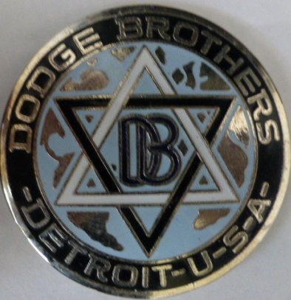
DODGE BROTHERS RALLY HAMILTON
3rd – 6th November 2017
ENTRY FORM
Name(s) ___________________________________________________________________________________
Address: ________________________________________________________________Post Code __________
Email ____________________ ______________________ Phone ____________________________________
VehicleDetails:_______________________________________________________Yesr:______________
_MEAL REQUIREMENTS:
Friday 3rd: Welcome Barbecue VVC Clubrooms) BYO Drinks) No______ @ $15.00 _________
Saturday 4th Morning Tea(Tabor Church Hall) No ___ ___ @ $7.00 __________ .. .. Lunch (Penshurst) No ______ @ $ 15.00 ___________ (Afternoon tea available for purchase at Byaduk Spring Flower Show.) .. .. Dinner (Hamilton Pastoral Museum BYO Liquor) No ______@ $22.00 _________
Sunday 5th Morning Tea(Hamilton Croquet Club) No ______ @ $ 9.00 __________ .. .. Lunch (Coleraine Bowling Club)) No ______ @ $12.00 __________ (BYO Afternoon Tea or purchase at local outlets) .. .. Dinner(Alexandra House – Drinks Bar Prices) No ______ @ $30.00 __________
Monday 6th: Farewell Breakfast (VVC Clubrooms) No______ @ $10.00 __________
.. Entry Fee: $ 30.00
. . .. TOTAL: $_______ PLEASE LIST ANY SPECIAL DIETARY REQUIREMENTS: ________________________________________________________________________________
________________________________________________________________________________
Entries close 30th Sept 2017, Please make cheques payable to DBCA Australia Inc. Or Direct Deposit to Bendigo Bank BSB 633 000 A/c 160087185 DBCA Rally Account. Please ensure you include surname in deposit. Post form back or scan and email to ralphgb45@bigpond.com OR Post entry with payment to: Dodge Rally P O Box 228 HAMILTON Vic 3300
Rally Conditions
All vehicles must be registered or on red plates with appropriate log book and must be roadworthy .The club reserves the right to alter, amend or cancel tour and whether or not to refund money paid should the entrant fail to attend all or part of the rally.
Indemnity In consideration of my application being accepted I undertake that I will at all times hereafter well and sufficiently indemnify the club and members thereof, their officials, servants and agents against all liability in respect of any actions, suits, proceedings, claims, demands, costs and expenses whatsoever which may be taken or made against the club and the members thereof their officials, servant and agents or incurred or become payable by any of them
SIGNED : _______________________________________________DATE: ______________________________________
DODGE BROTHERS CLUB OF . AUSTRALASIA INC.
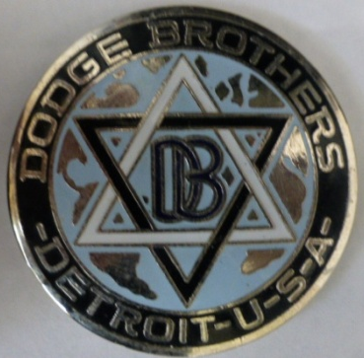
Victoria “Tweeny “ Rally 3rd-6th November 2017Hamilton
Rally Headquarters will be the Hamilton and District V.V.C. Drivers Club Vintage Garage Clubrooms at the Pastoral Museum in Hiller Lane off Ballarat Road.
ITINERARY:( May vary slightly)
Friday 3rd Nov: Welcome Barbecue at Rally Headquarters Saturday 4th Nov: Volcanic Trail Tour. Tour through Lakes district. Morning Tea at historic Tabor Church and Hall. Lunch in Penshurst Township. Attractions: Schramm’s Vintage Garage. Volcano Discovery Centre. Courthouse History Centre etc, Afternoon short drive to Byaduk Village. Visit Byaduk Spring Flower Show, Antique General Store. Vintage Clothing Museum. . Hamilton : Evening Dinner with Entertainment at Pastoral Museum. Sunday 5th Nov: Historic Hamilton Homes. Morning Tea at Quaint Croquet Club. Scenic back roads drive to Coleraine Township via Wannon Falls.. Lunch at Bowling Club.. Classic Car Museum. Chocolate Factory. Railway Station Museum, etc. Evening meal at Alexandra House Hamilton. Fellowship and awards Monday 6th Nov: Farewell Breakfast at Rally Headquarters. Local attractions for anyone staying on: Ansett Museum. Campe’s Motor Museum. Art Gallery etc.

MEALS : Friday evening: Barbecue/Tea/Coffee. BYO drinks
Saturday : Lunch: Salad Rolls/Slices/Tea/Coffee . Dinner; two course, Roast main course/Tea/Coffee. BYO drinks
Sunday: Lunch: Soup/Sandwiches/Sweets/Tea/Coffee . Dinner: Two courses, alternate serves. Drinks at bar prices.
Monday: Breakfast: Egg & Bacon Rolls/juice /Tea/Coffee

